Name: __________________________________ Score: ____ /10

**Vibration of Greenhouse Gases Activity**

***Part 1: Molecular Structure*** Use the 3-D models to sketch one unit of each atmospheric gas.

|  |  |  |
| --- | --- | --- |
| **N2 (Nitrogen)** | **O2 (Oxygen)** | **CO2 (Carbon dioxide)** |
| **CH4 (Methane)** | **H2O (Water vapor)** | **Ar (Argon)** |

***Part 2: Molecular Vibration*** <https://www.chem.purdue.edu/jmol/vibs/index.html>

Molecules (groups of atoms bonded together) vibrate. A single molecule can vibrate in various ways; each of these different motions is called a **vibration "mode."** Use this website written above to view the vibrational modes for each of the atmospheric molecules and answer the questions below

1. How do the molecules made of **two atoms** vibrate?
2. How do the molecules made of **three atoms** vibrate?
3. How many different ways does **methane** vibrate? Why do you think this happens?
4. Why does **Argon** have zero vibrational modes?

Molecules with more (and more complex!) vibration modes are more likely to interact with passing waves of electromagnetic radiation. This is why greenhouse gases, like CO2, absorb and emit **infrared radiation** and which causes increased atmospheric warming.

1. CO2 and H2O are considered a greenhouse gases, while N2 and O2 are not.
   1. Based on what you learned so far, which of the remaining atmospheric gases are greenhouse gases? EXPLAIN YOUR REASONING!
   2. Which of the atmospheric gases are not greenhouse gases? EXPLAIN YOUR REASONING!

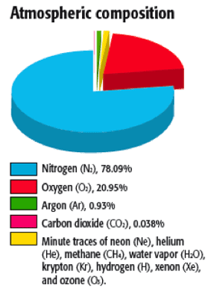***Part 3: Atmospheric Composition***

1. What percent of the atmosphere is made of greenhouse gases?
2. Watch the video *Steroids, baseball, and climate change* (link below the chart). Based on what you’ve learned, how could you respond to someone that says: *“There’s no need to worry greenhouse gases since they make up such a small part of our atmosphere. The scientists are making a big deal out of nothing.”*?

<https://www.youtube.com/watch?v=MW3b8jSX7ec>